MEDIA ALERT

PLEASE CONTACT US IF WE CAN HELP ASSIST WITH YOUR COVERAGE ARRANGEMENTS – WE CAN HELP TO SET UP ADVANCE INTERVIEWS AND STORY SHOOTS WITH GROWERS
FOR PREVIEW STORY/BEST BETS/HIGHLIGHT BOX/CALENDAR LISTINGS
MEDIA CONTACT: Tim Beeman 415-999-2428 / Ronan Fowler 415-236-2601
WEBSITE: http://weighoff.miramarevents.com
ALL MEDIA KIT ASSETS: https://weighoff.miramarevents.com/media-contact.html
FACEBOOK LIVESTREAM: https://www.facebook.com/halfmoonbaypumpkinweighoff/

PLANNING NOTE: For the early 5-7 am news (prior to the actual weighing on Monday, Oct. 9), we'll have several returning champions and top contenders at the weigh-off site from 5-7 am with pumpkins in tow for early, pre-weighing interviews – another option would be to set-up a segment with a grower tending their patch in the days leading up to the weigh-off. Press parking will be available adjacent the weigh-off staging area for easy access – we have designated space for satellite trucks and broadcast vehicles with assistance from event staff.
- Godzilla Gourds Get Ready to Rock the Scales in Half Moon Bay
- Milestone 50th Safeway World Heavyweight Championship, Monday, October 9
- Superstar Growers Butt Gourds at the Super Bowl of Weigh-Offs for the World’s Biggest Top Prize of $9/Pound
- Plus $30k Total Mega-Prize at Stake for a New World Record Pumpkin
- New Scale Purchased to Fit the Rhinoceros-Sized Gourds Coming for the Weigh-Off
- Will the World Record Be Squashed This Year? Inquiring Minds Want to Know
- Debut of Weigh-Off Wall of Fame Mural and Plaque Installation & Pumpkin King Champions Ring
- IDES Grounds, 735 Main Street, Half Moon Bay
- Follow the Weigh-Off Livestream on Facebook
PLUS, NEWS FROM THE HALF MOON ART & PUMPKIN FESTIVAL
- One of America’s Most Iconic Festivals Returns...Pumpkin Festival Marks 51 Epic Years!
- Pumped Up Pumpkin Mecca Gears Up for Half Moon Bay’s World-Famous Celebration of the Great and Almighty Gourd
- 51st Half Moon Bay Art & Pumpkin Festival, October 14-15
HALF MOON BAY, CALIFORNIA (October 4, 2023) –– Will the ungodly world heavyweight record of 2,702 pounds get squashed by a Volkswagen-sized pumpkin this year In Half Moon Bay? No weigh? Weigh! Bring it on beefy, brawny, burly behemoths!
The excitement is building in Pumpkintown as the World’s Greatest Gourd Growers and their Goliath, mind-blowing, Rhinoceros-sized orange orbs hope to crush the world record on the morning of Monday, October 9 at the Safeway World Championship Pumpkin Weigh-Off –– in the World Pumpkin Capital of Half Moon Bay, California –– the kick-off to a big week of events culminating with Half Moon Bay’s world-famous Art & Pumpkin Festival which returns for its 51st rendition on October 14-15.
It’s always a sight to behold. Every year on weigh-off reckoning day the streets around downtown Half Moon Bay are lined with sagging, overloaded trucks and trailers crammed with burly orange behemoths quietly awaiting their place of destiny in the worldwide media spotlight or the Libby's canning factory, their massive roots firmly planted in buckets of water to prevent weight loss as fans ooh and aah at their sheer, stunning enormity.
This year, weigh-off organizers and title sponsor Safeway celebrate the robust lineup of superstar growers with the world’s biggest prize money pool.
Using a pay-by-the-pound system, the ginormous top prize of $9/pound will be awarded to the weigh-off champion. Also at stake are thousands of dollars in super hefty prize money doled out to the top 20 plus the big carrot: a $30,000 total mega-prize for a new world record pumpkin entered at Half Moon Bay (the current world record is 2,702-pounds set at a 2021 weigh-off in Italy).
Defending champion Travis Gienger's leviathan 2,560-pound mega-gourd set a new North American record and handily won the 2022 Safeway World Championship Pumpkin Weigh-Off in Half Moon Bay.
A host of accomplished veteran growers are expected to contend for the coveted title including Gienger who's growing and driving out from Anoka, MN while hauling out an even larger pumpkin than last year, currently more than 7.5 feet wide.
The immense girth of Gienger's beast has required weigh-off organizers to purchase a new scale to accommodate its enormity.
The weigh-off champion will be feted and play a starring role in the world-famous Half Moon Bay Art & Pumpkin Festival, Oct. 14-15 (including a free weekend at the posh, pumpkin-centric Ritz-Carlton on the stunningly beautiful Half Moon Bay coast).
The winner will also receive the inaugural Pumpkin King Champions Ring and coveted Mel Mello Sr. Grand Champion Growers Jacket and all growers receive a gift bag packed with local treasures like bottles from Half Moon Bay Winery and Half Moon Bay Brewing Company.
Beauty will share center stage with beefy brawn with a $1000 prize awarded for the “Joe Cotchett Family Most Beautiful Pumpkin” as judged by the audience based on color, shape and size.
Additional special bonus prizes include: Biggest California Pumpkin — $1,000; Biggest Coastside Pumpkin — $1,000.
Using forklifts and special harnesses, the gargantuan gourds will be carefully placed on a 5-ton capacity, industrial-strength digital scale under the watchful eye of officials from the San Mateo County Agricultural Commissioner's Office of Weights, Sealers, and Measures. Half Moon Bay’s Weigh-Off will serve as an officially sanctioned Great Pumpkin Commonwealth (GPC) site.
The official weighing will take place on Monday, October 9th from 7 a.m. to approximately 11 a.m. followed by the awards presentation and luncheon on the I.D.E.S. Grounds, 735 Main Street in Half Moon Bay. Spectators are welcome. Admission is free.
The grand champion gourd (along with the top four overall) will be on display plus there's a special weigh-off champion pumpkin photo booth at the Half Moon Bay Art & Pumpkin Festival, October 14-15, from 9 a.m. to 5 p.m. on Main Street.
SPECIAL FLOURISHES ADDED TO MARK MILESTONE 50TH HALF MOON BAY WEIGH-OFF
This year marks the milestone 50th anniversary of Half Moon Bay’s now world-famous Safeway World Championship Pumpkin Weigh-Off and the organizing team announced some of the special flourishes in the works to celebrate its fascinating story and proud history.
There are dazzling, one-of-a-kind rings to honor Super Bowl, World Series, and NBA champions and now there is Half Moon Bay’s one and only Pumpkin King Champions Ring that will be awarded to the winner along with the $9 per pound top prize and the coveted Mel Mello Sr. Grand Champion Growers Jacket.
The spectacular ring is designed and sponsored by Josh Warshauer, second generation owner of Goldworks on Main Street in Half Moon Bay. The ring is sterling silver with the weigh-off logo in a 14kt yellow gold top plate with the winner’s name and pumpkin weight engraved on the inside.
Also planned is a special display of historic weigh-off photos from 1974 to today that will be shown at the weigh-off plus a special Weigh-Off Wall of Fame Mural and Plaque Installation that will be on the Cunha Grocery wall on Kelly Avenue.
Coastside artist Julie Engelmann, who created the remarkable landmark mural in 2022 to honor the 50th Pumpkin Festival, has designed and is painting a new adjacent mural to frame and surround the special bronze cast Weigh-Off Wall of Fame Champions Plaque and Honorary Inductees Plaque.
Founding underwriters include Joseph W. Cotchett, Half Moon Bay Winery, Half Moon Bay Brewing Company, Safeway, the Half Moon Bay Beautification Committee and Miramar Events.
For information on the weigh-off, visit http://weighoff.miramarevents.com
––
FOR BEST BETS/HIGHLIGHT BOX/CALENDAR LISTINGS
WEBSITE: http://weighoff.miramarevents.com
ALL MEDIA KIT ASSETS: https://pumpkinfest.miramarevents.com/media-press-kit.html
FACEBOOK LIVESTREAM: https://www.facebook.com/halfmoonbaypumpkinweighoff/

50TH SAFEWAY WORLD CHAMPIONSHIP PUMPKIN WEIGH-OFF
WORLD HEAVYWEIGHT CHAMPIONSHIP OF GOLIATH GOURDS
WORLD’S BIGGEST TOP PRIZE OF $9 PER POUND
AND $30K IN TOTAL PRIZE MONEY FOR A NEW WORLD RECORD PUMPKIN
MONDAY, OCTOBER 9, 2023 – 7 A.M. TO 11 A.M.
I.D.E.S. GROUNDS – 735 MAIN STREET – HALF MOON BAY, CALIFORNIA

WHAT: No weigh. Weigh!!! Bring it on burly, beefy, bodacious behemoths! The excitement is building in Pumpkintown as the World’s Greatest Gourd Growers and their Goliath, mind-bending, Rhinoceros-sized orange orbs hope to squash the world record on Monday, October 9 at the Safeway World Championship Pumpkin Weigh-Off –– the “Super Bowl of Weigh-Offs” –– in the World Pumpkin Capital of Half Moon Bay, California and this year organizers, in association with title sponsor Safeway, are upping the ante big time to celebrate the robust lineup of superstar growers.
Using a pay-by-the-pound system, the world’s biggest top prize of $9/pound will be awarded to the weigh-off champion. Also at stake are thousands of dollars in super hefty prize money doled out to the top 20 plus the big carrot: a $30,000 total mega-prize for a new world record pumpkin entered at Half Moon Bay (the current world record is 2,702-pounds set at a 2021 weigh-off in Italy). The winner will also receive the inaugural Pumpkin King Champions Ring and coveted Mel Mello Sr. Grand Champion Growers Jacket.
Defending champion Travis Gienger's leviathan 2,560-pound mega-gourd set a new North American record and handily won the 2022 Safeway World Championship Pumpkin Weigh-Off in Half Moon Bay. A host of accomplished veteran growers are expected to contend for the coveted title. The champion will be feted and play a starring role in the world-famous Half Moon Bay Art & Pumpkin Festival, Oct. 14-15 (including a free weekend at the posh, pumpkin-centric Ritz-Carlton on the stunningly beautiful Half Moon Bay coast).
Beauty will share center stage with beefy brawn with a $1000 prize awarded for the “Joe Cotchett Family Most Beautiful Pumpkin” as judged by the audience based on color, shape and size.
The grand champion gourd (along with the top four overall) will be on display plus there's a special weigh-off champion pumpkin photo booth at the Half Moon Bay Art & Pumpkin Festival, October 14-15, from 9 a.m. to 5 p.m. on Main Street.
Admission is free. Open to the public.

WHEN: Monday, October 9, 2023. Weighing will take place from 7 a.m. to approximately 11 a.m.
WHERE: IDES Grounds, 735 Main Street, Half Moon Bay, California. Press parking will be available on Main Street directly in front of the IDES Grounds staging area for easy access.
WEBSITE: http://weighoff.miramarevents.com
––
PHOTO CAPTION (300 dpi jpeg) ––– Photo Credit: Miramar Events
Defending champion Travis Gienger's leviathan 2,560-pound mega-gourd set a new North American record and handily won the 2022 Safeway World Championship Pumpkin Weigh-Off in Half Moon Bay. A host of accomplished veteran growers are expected to contend for the coveted title. Legendary Gourd Growing Greats and their Goliath, mind-bending, Rhinoceros-sized orange orbs gather on the morning of Monday, October 9 for the Safeway World Championship Pumpkin Weigh-Off. The grand champion mega-gourd, along with the top four heaviest pumpkins from the weigh-off, will be on display at the world-famous Half Moon Bay Art & Pumpkin Festival on October 14-15 from 9 a.m. to 5 p.m.

2022 champion Travis Gienger and his winning 2,560-pound mega-gourd
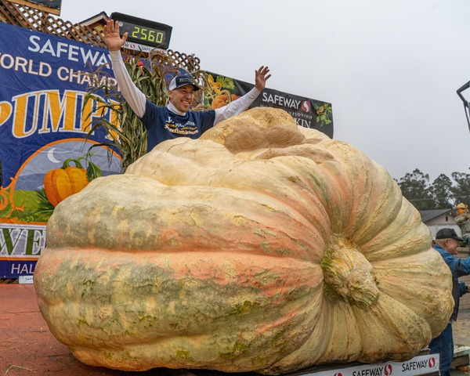

Past champion grower Cindy Tobeck of Little Rock, WA with her 2022 entry, winning 4th place at 1,671 pounds.
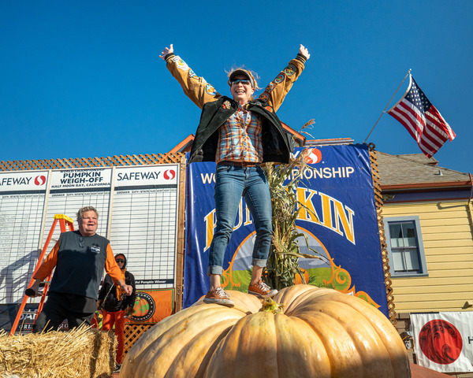
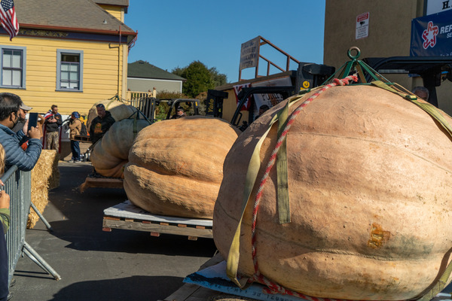
Special display of monster pumpkins at the Half Moon Bay Art & Pumpkin Festival
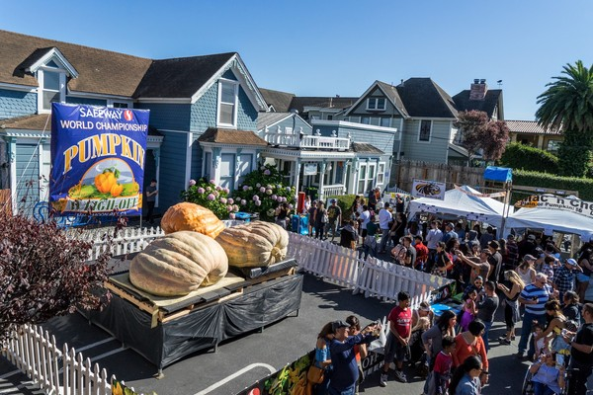
Farmer Mike, the Picasso of Pumpkin Carvers, doing his thing at the Half Moon Bay Art & Pumpkin Festival
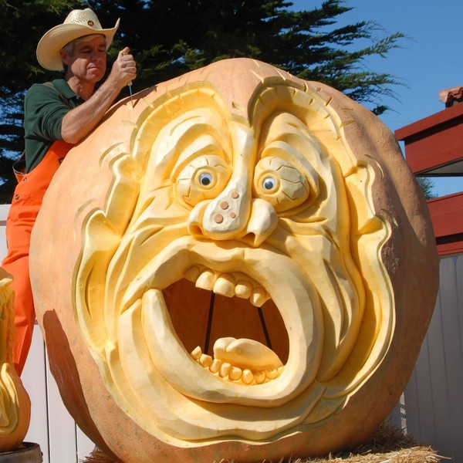

Pumpkin King Champions Ring

Weigh-Off Wall of Fame Mural and Plaque Installation mockup
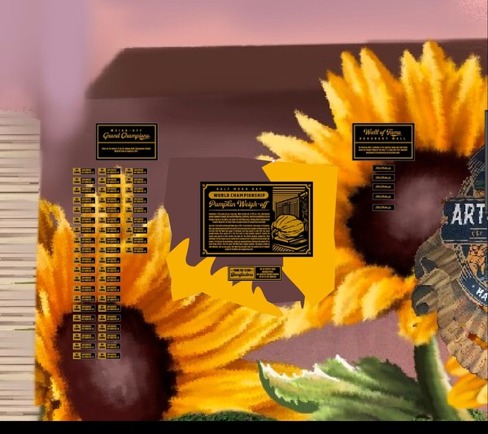

Main Plaque
